EENG 385 - Electronic Devices and Circuits

Lab 9 – Active Filters

Lab Handout

# Objective

The objective of this lab is to study the design of the filters on the audio board and measure their performance.

**Filter Background**

An ideal filter allows a range of frequencies to pass through the filter unchanged. This range of frequencies is called the passband. Frequencies outside the passband cannot pass through the filter. Thus, a filter is an electronic device whose output depends on the frequency of the input signal.

In the real world, ideal filters do not exist. Instead, real filters reduce, but do not eliminate, signals outside the passband. The reduction of a signal’s amplitude from input to output is called attenuation and is measured in units of decibels.

* A positive decibel value means the amplitude of the output is larger than the input.
* A decibel value of 0 means the output has the same amplitude as the input.
* Negative decibels means that the amplitude of the output is smaller than the input.

# The goal of this lab is to plot attenuation vs. frequency for all four filters on your Audio board. These plots are called Bode plots.

**Filter Behavior Simulation**

**Low-Pass Filter**

Your audio board comes equipped with a 2nd order low-pass filter shown in Figure 3. This circuit is called a “low-pass filter” because it allows low frequency sine waves that are applied to the input (LPF_IN in Figure 3) to pass through to the output (LPF_OUT in Figure 3) largely unchanged, hence “low-pass”. However, when you apply a high frequency waveform to the input, it will emerge from the output with a much smaller amplitude. What constitutes “high” and “low” frequency is determined by the component values in the circuit.

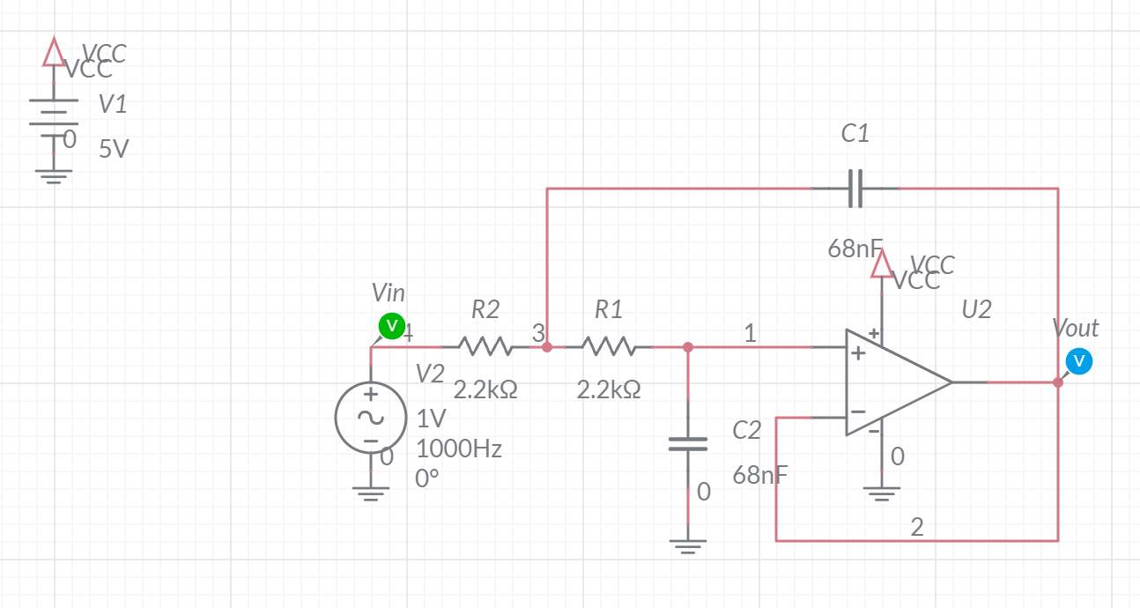

Figure : The low-pass filter on the Audio board built with a Sallen-Key topology.

A filter topology is an arrangement of components that realizes the filter. Our audio board has a 2nd order low-pass filter constructed with a Sallen-Key topology.

To understand the behavior of our low-pass filter, let’s construct the circuit in Figure 3 using MultiSim Live. Use the components and values given in the figure. In case you need it, here is the parts list from Multisim Live.

|  |  |  |
| --- | --- | --- |
| Component | Tool | Name |
| DC Voltage | Sources | DC Voltage |
| AC Voltage | Sources | AC Voltage |
| Ground | Schematic connectors | Ground |
| VCC | Schematic connectors | Connector |
| Resistor | Passive | Resistor |
| Capacitor | Passive | Capacitor |
| Op amp | Analog | 5 Terminal Opamp |

You will also need to put a pair of probes on the input and output. Take a moment to change the labels of these probes to Vin and Vout. You can do this by double clicking on the probes and using the component properties pull-out to change the ID field. Once you have constructed and setup, let’s apply some sine waves and observe the behavior of our low-pass filter in the time domain.

The op amp in Figure 3 (and on your audio board) is powered from a single rail, meaning 5V and 0V. This can cause problems for signals that have no DC bias. “No DC bias” means that the AC waveform is centered at 0V. As a reminder the audio input to your Audio board has no DC bias – it is about 1.0V peak-to-peak and centered at 0V.

Let’s see what the low-pass filter would do to an AC input with no DC bias. To do this, make the following changes to the AC source and simulation. To edit the AC source properties, double click on the source and edit the fields in the properties pull-out.

* AC Voltage Freq = 1000Hz VA = 0.5V VO = 0V
* Simulation End Time = 4ms

Run the simulation by pressing the play button on the top menu bar. View the output by clicking on the Grapher or Split buttons in the top menu bar.

1. With no DC bias applied to the input AC source, is the output of the low-pass filter an accurate reproduction of the input?

**The output is not a faithful reproduction of the input, because the output is clipped.**

Now let’s provide a DC bias to the AC input so that the 1V peak-to-peak input it is centered at 0.5V. To do this make the following changes to the AC source.

* AC Voltage Freq = 1000Hz VA = 0.5V VO = 0.5V
* Simulation End Time = 4ms

After you run the simulation, your Grapher output should looks like Figure 4.

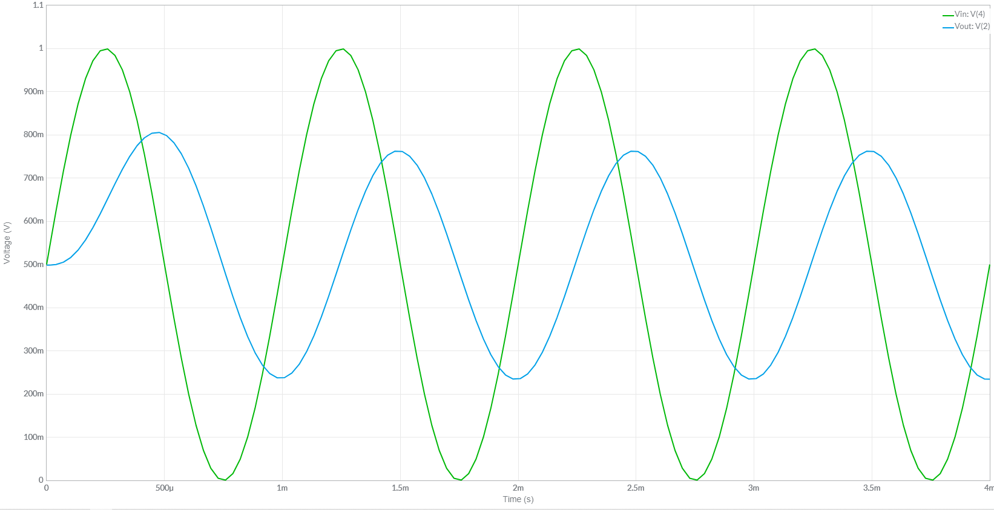

Figure : A 1000Hz input waveform (in green) and the output(blue) from the low-pass filter.

From this graph, you should be able to see (and measure) that the output waveform has a lower amplitude than the input. This change in amplitude, from input to output, is called attenuation. Mathematically, attenuation is the ratio of the output over the input. This is done to normalize the output amplitude in terms of the input amplitude. Furthermore, since we will be measuring a large range of attenuations, we will measure attenuation in the units of decibels by using the following equation.

Using the cursor in Grapher tab of the MultiSim simulation, I measured:

* The input waveform to be 1.00V peak-to-peak
* The output waveform to be 0.525V peak-to-peak

Thus at 1,000 Hz, the low-pass filter has 20*log(0.525/1.00) = -5.6dB of attenuation. Note that I set the input waveform to 1V peak-to-peak so you will not have to measure its amplitude using the cursor in MultiSim.

In addition to the change in the amplitude of the output, the output waveform (blue in Figure 4) is shifted to the right. This shift in time is called phase delay. Phase delay is measured in the number of degrees that the output waveform occurs with respect to the input waveform. Let’s explore this definition using Figure 4. Choose any peak of the input (green waveform in Figure 4), say the one at 2.25ms. Now look for the peak in the output (blue waveform in Figure 4), that immediately follows the peak in the input waveform. This occurs at 2.47ms. Now divide the time different between these two peak by the period of the waveform. This bit of math yields (2.25ms – 2.47ms)/1ms = -0.22. Multiply this value by 360° to get the phase delay. In our case, this is -0.22*360° 1= -79°.

Now we will measure the change in amplitude and phase for a variety of frequencies, record them, and then use this information to build a Bode plot. Download and open the filterWorkSheet from Go to the LPFsim tab and fill in value for Vout/Vin for 1000Hz row. In other words, enter 0.525 in cell C9. The corresponding decibel entry in the Attenuation column will auto-populate. Next enter the time delay between the peaks of the input and output waveforms in units of milliseconds in the Delta (ms) column. In other words, enter 0.22 in cell E9. The corresponding Phase entry in the Phase column will auto-populate.

Now change the frequency of the input waveform in MultiSim to every frequency value in column B that is not already filled in. Cut-and-paste your attenuation and phase plots as the answer for this section. Some technical notes:

* When you get to higher frequencies, the amplitude of the output waveform will be so small that it becomes hard to measure. When this happens zoom in the vertical axis by scrolling the center mouse wheel on the vertical axis.
* You can grab and slide the vertical axis to center it while zooming.
* The output waveform will not stay centered at 1.0V. You should determine the amplitude by subtracting the lowest point of the output wave from the highest.
* To measure the phase, I found a peak of the output near a marked position on the time axis, then zoomed on the vertical axis until I could measure the time of the input peak.

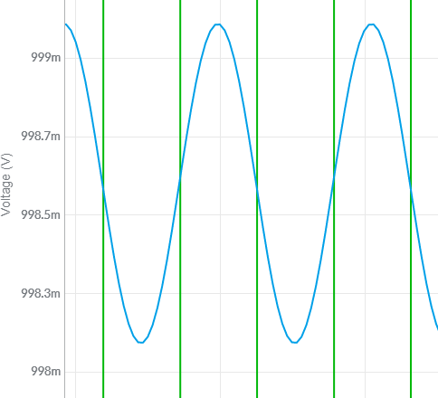

1. Include a copy of your Excel data for the Bode plot. That is cells B3 throughF14. A screen shot using the snipping tool would be satisfactory.

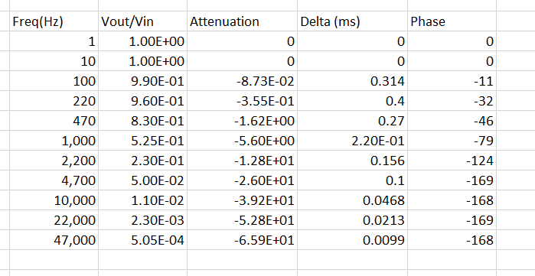

1. Include a copy of your Bode plot from Excel as the answer to this question. A screen shot using the snipping tool would be satisfactory.

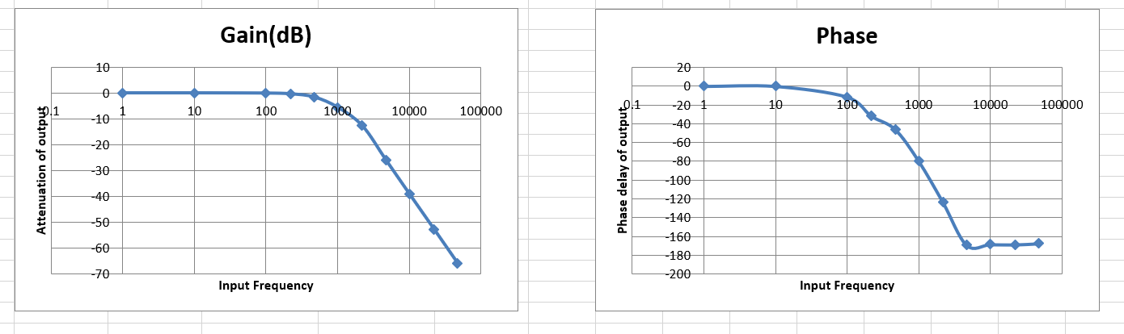

Now that you have a solid understanding of how a low-pass filter operates, let’s look at the behavior from the theoretical point of view.

The corner frequency of a 1st order filter is defined as the frequency at which the attenuation is down by -3dB. Since we are working with a 2nd order filter, attenuation at the corner frequency will be down by -6dB. Numerically, this frequency is given by the following equation. Note the component references are to Figure 3.

1. Given the component values in Figure 3, what is corner frequency of the low-pass filter on the audio board?

**The corner frequency of the low-pass filter in Figure 3 is 1.06kHz.**

1. Given the data that you collected from the Multisim Live simulation, what is the corner frequency of the low-pass filter?

**The corner frequency of the simulated low-pass filter is a little above 1.0kHz.**

Now that you have gone through the painful process of building a Bode plot by hand, you will be delighted to know there is a far easier method to do this, have Multisim do it for you. The AC Sweep function of MultiSim causes the simulator to run a series of simulations of your design. Each simulation:

* Will have an incrementally higher frequency for the AC source. You set the range of frequencies for the AC source,
* Will record the amplitude of each probe in the circuit in decibels with respect to the amplitude of the AC source,
* Will record the phase of each probe in the circuit in degrees with the phase of the AC source being 0°,

The Grapher will display the recorded data as magnitude and phase versus frequency. The frequency axis is logarithmic, forming a Bode plot for each probe in the circuit.

Let’s try this out for our low-pass filter. To start, you will need to change the simulation type to AC Sweep.

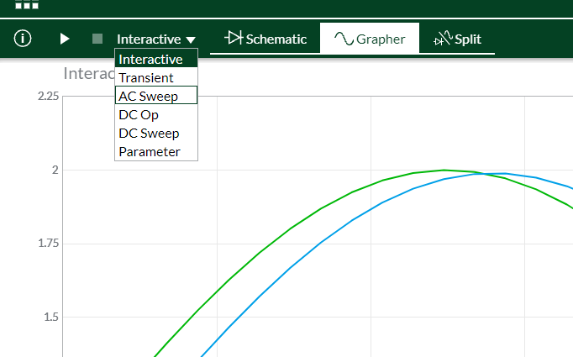

Next, you will need to configure the AC Sweep. Let’s create a Bode plot using the same frequencies you used to create your Bode plot in Excel. Double click on the schematic to reveal the simulation settings pull-out. Use the following settings:

* Start frequency 1Hz
* Stop frequency 47kHz
* Points per decade 20
* Vertical scale Decibels

Now run the simulation. On the Grapher output, isolate the magnitude of Vout by removing the phase and magnitude of Vin by clicking on the filled check boxes by their names in the pull-out. The Grapher output has the attenuation scale on the left axis and the phase scale on the right side of the graph.

You can download a nice image of the Grapher output by clicking on the 3x3 grid of squares in the upper left corner of the Multisim window and selecting Export -> Grapher image. Your browser should download the png file.

1. Include your Bode plot for the output as your answer to this question.

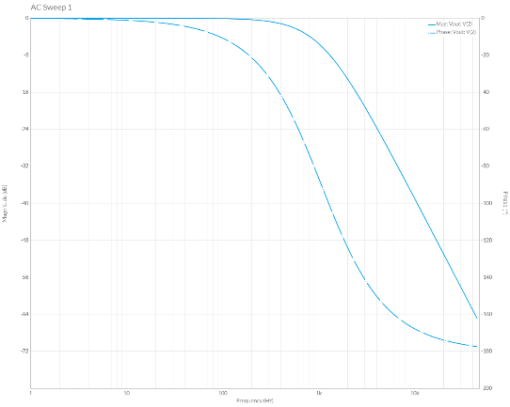

Before you proceed, take a few moments and verify that the Bode plot you made in Excel closely matches the Bode plot formed by the AC Sweep in MultiSim. Fix any problems before proceeding.

**High-pass Filter**

Your audio board comes equipped with a 2nd order high-pass filter shown in Figure 5. This circuit is called a “high-pass filter” because it allows high frequency sine waves that are applied to the input (HPF_IN in Figure 5) to pass through to the output (HPF_OUT in Figure 5) largely unchanged, hence “high-pass”. However, when you apply a low frequency waveform to the input, it will emerge from the output with a much smaller amplitude. What constitutes “high” and “low” frequency is given by the corner frequency, which is in turn is determined by the component values in the circuit.

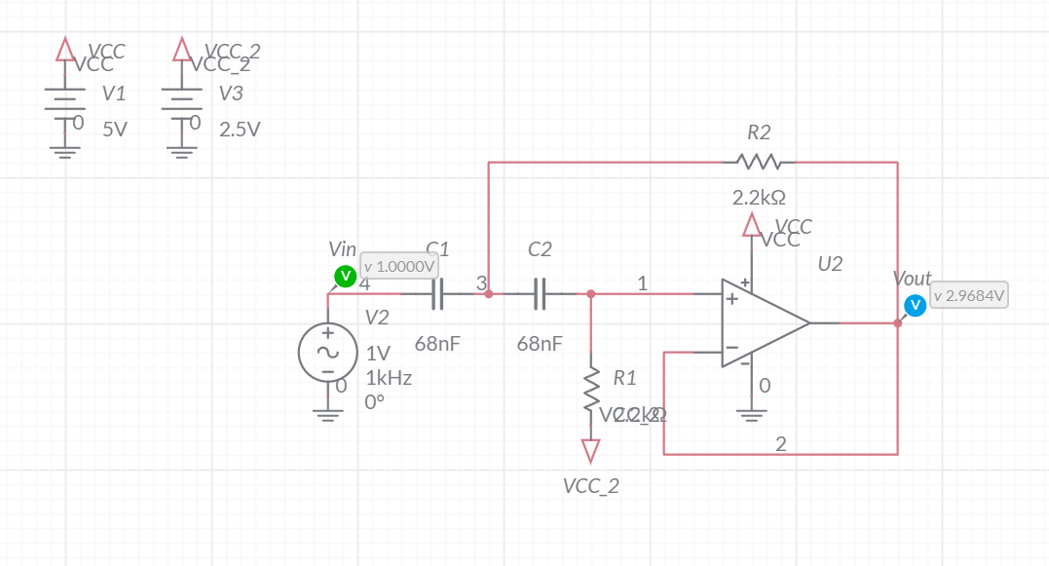

Figure : The high-pass filter on the audio board requires a split supply to properly center the output waveform.

The presence of the VCC/2 voltage (which is VCC_2 in Figure 5) to the resistor R1, properly biases the op amp output to half the supply voltage VCC. On your audio board, VCC is set to 5V, and the 2.5V Zener diode provides the VCC/2 voltage. You will need to include a pair of DC supplies for this voltage as shown in Figure 5.

To understand the behavior of our high-pass filter, let’s construct the circuit in Figure 5 using MultiSim Live. Use the components and values given in the figure. In case you need it, here is the parts list from Multisim Live.

|  |  |  |
| --- | --- | --- |
| Component | Tool | Name |
| DC Voltage | Sources | DC Voltage |
| AC Voltage | Sources | AC Voltage |
| Ground | Schematic connectors | Ground |
| VCC | Schematic connectors | Connector |
| Resistor | Passive | Resistor |
| Capacitor | Passive | Capacitor |
| Op amp | Analog | 5 Terminal Opamp |

Since our op amp in Figure 5 is powered from a single rail, we may have issues with signals that have no DC bias. Let’s see what the high-pass filter does with an AC input with no DC bias. To do this, make the following changes to the AC source and simulation. To edit the AC source properties, double click on the source and edit the fields in the properties pull-out.

* AC Voltage Freq = 1000Hz VA = 0.5V VO = 0V
* Simulation End Time = 4ms
* Simulation Type Interactive (not AC Sweep)

Run the simulation by pressing the play button on the top menu bar. View the output by clicking on the Grapher or Split buttons in the top menu bar.

1. With no DC bias applied to the input AC source, is the output of the low-pass filter an accurate reproduction of the input? You should ignore any DC bias added to the output.

**The output is a faithful reproduction of the input.**

The corner frequency of our 2nd order high-pass filter is the frequency where the attenuation is -6dB. Numerically, this frequency is given by the following equation. Note the component references refer to the components in Figure 5.

This equation is identical to the corner frequency of a low-pass filter because the topologies are identical if resistors are swapped with capacitors.

1. Given the equation above and the component values in Figure 5, what is corner frequency of the low-pass filter on the audio board?

**The corner frequency of the high-pass filter is 1.06kHz.**

Generate the Bode plot for the high-pass filter in Multisim using the following simulation settings:

* Start frequency 1Hz
* Stop frequency 47kHz
* Points per decade 20
* Vertical scale Decibels

Now run the simulation. On the Grapher output, isolate the magnitude of Vout by removing the phase and magnitude of Vin by clicking on the filled check boxes by their names in the pull-out.

1. Include the Grapher output of your Bode plot as the answer to this question. Use the export Grapher image feature.

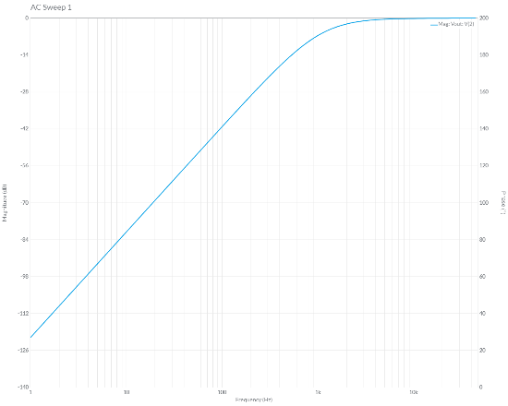

1. Compare the corner frequency you calculated using the equation against the -6dB frequency from the Bode plot. Are they close?

**The calculated -6dB frequency is 1.06kHz, the -6dB frequency from the Bode plot is almost identical.**

**Band-pass Filter:**

Your audio board comes equipped with a band-pass filter shown in Figure 5. This circuit is called a “band-pass filter” because it allows a band sine wave frequency to pass through largely unchanged, hence “band-pass”. However, when you apply a low or high frequency waveform to the input, it will emerge from the output with a much smaller amplitude. What constitutes “high” and “low” frequency is determined by the component values in the circuit.

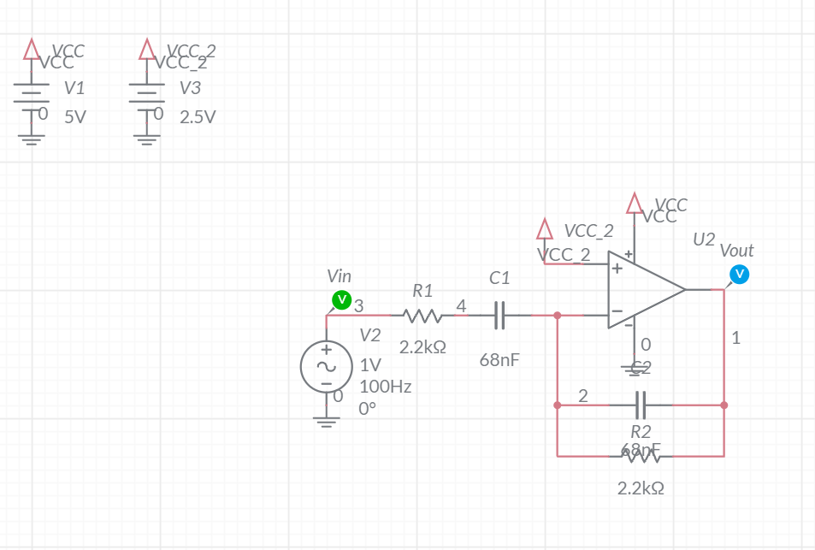

Figure : The band-pass filter on the audio board.

To understand the behavior of out band-pass filter, let’s construct the circuit in Figure 6 using MultiSim Live. Use the components and values given in the figure. In case you need it, here is the parts list from Multisim Live.

|  |  |  |
| --- | --- | --- |
| Component | Tool | Name |
| DC Voltage | Sources | DC Voltage |
| AC Voltage | Sources | AC Voltage |
| Ground | Schematic connectors | Ground |
| VCC | Schematic connectors | Connector |
| Resistor | Passive | Resistor |
| Capacitor | Passive | Capacitor |
| Op amp | Analog | 5 Terminal Opamp |

Since our op amp in Figure 6 is powered from a single rail, we may have issues with signals that have no DC bias. Let’s see what the high-pass filter does with an AC input with no DC bias. To do this, make the following changes to the AC source and simulation. To edit the AC source properties, double click on the source and edit the fields in the properties pull-out.

* AC Voltage Freq = 1000Hz VA = 0.5V VO = 0V
* Simulation End Time = 4ms
* Simulation Type Interactive (not AC Sweep)

Run the simulation by pressing the play button on the top menu bar. View the output by clicking on the Grapher or Split buttons in the top menu bar.

1. With no DC bias applied to the input AC source, is the output of the low-pass filter an accurate reproduction of the input? You should ignore any DC bias added to the output.

**The output is a faithful reproduction of the input.**

Generate the Bode plot in Multisim using the following simulation settings as follows:

* Start frequency 1Hz
* Stop frequency 47kHz
* Points per decade 20
* Vertical scale Decibels

Now run the simulation. On the Grapher output, isolate the magnitude of Vout by removing the phase and magnitude of Vin by clicking on the filled check boxes by their names in the pull-out.

1. Include the Grapher output of your Bode plot as the answer to this question. Use the export Grapher image feature.

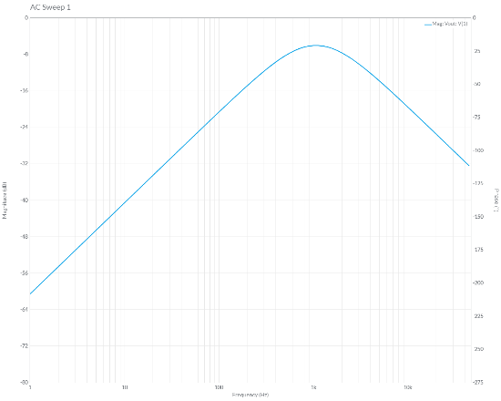

There are a variety of bandpass filters types, ours has a center frequency where the output is -6dB down. Numerically, this frequency is given by the following equation.

Because the output is always smaller than the input, this is not an ideal filter for our audio application. That said, it is the one that we will be using.

1. Compare the center frequency you calculated using the equation against the -6dB frequency from the Bode plot. Are they close?

**The calculated -6dB frequency is 1.06kHz, the -6dB frequency from the Bode plot is almost identical.**

**Level Shifter**

The audio signal input to your audio board has no DC bias – it is centered around 0V. This means that the audio waveform spends ½ its time below 0V and risks being clipped because our op amp are powered with 5V and GND. Thus, I included the circuit in Figure 7. This circuit is a level-shifter, it adds a DC bias to the AC input. The DC bias is set using the 100k potentiometer in Figure 7.

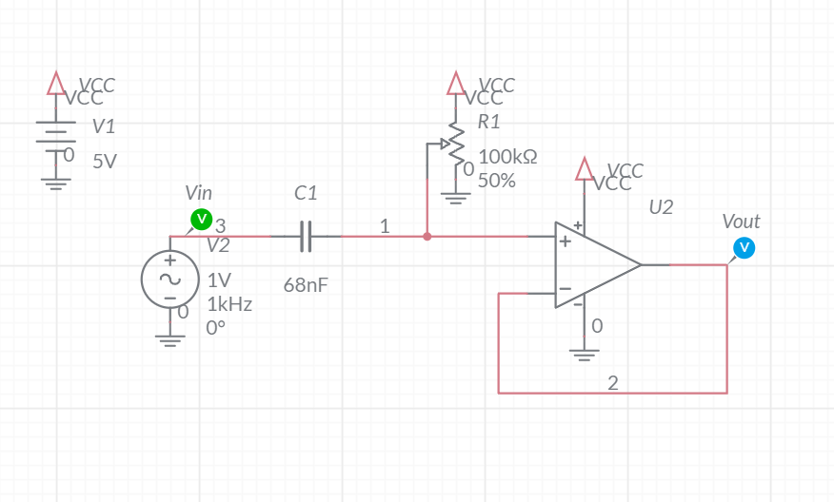

Figure : The level-shifter AC couples a signal onto a DC bias set by the potentiometer.

To understand the behavior of our level-shifter, let’s construct the circuit in Figure 7 using MultiSim Live. Use the components and values given in the figure. In case you need it, here is the parts list from Multisim Live.

|  |  |  |
| --- | --- | --- |
| Component | Tool | Name |
| DC Voltage | Sources | DC Voltage |
| Ground | Schematic connectors | Ground |
| VCC | Schematic connectors | Connector |
| Potentiometer | Passive | Potentiometer |
| Capacitor | Passive | Capacitor |
| Op amp | Analog | 5 Terminal Opamp |

Let’s experiment with the POT settings and see how the waveform is affected. To do this set the POT to 90% by changing its PosPercent property to 90.

1. Look at the POT schematic symbol after changing its PosPercent, did the center tap move closer to the VCC or GND terminal?

**The center tap moved 90% of the way to the GND terminal.**

1. What would you expect the DC voltage out of the potentiometer to equal?

**The potentiometer will output 10% of 5V or 0.5V.**

Now run a simulation using the following settings.

* AC Voltage Freq = 1000Hz VA = 1V VO = 0V
* Simulation End Time = 4ms
* Simulation Type Interactive (not AC Sweep)

Run the simulation by pressing the play button on the top menu bar. View the output by clicking on the Grapher or Split buttons in the top menu bar.

1. With the 0.5V DC bias applied to the input AC source, is the output of the level-shifter an accurate reproduction of the input? You should ignore any DC bias added to the output.

**The output is not a faithful reproduction of the input because the output is clipped at ground.**

1. What is the smallest DC bias voltage you would need to the AC input in order to avoid clipping? Test your answer.

**We would have to set the potentiometer to 80% to generate a 1V DC bias. This would cause the output waveform to just touch 0V at its lowest point.**

Unintentionally, the level shifter acts like a high-pass filter. To see this, let’s generate the Bode plot in Multisim using the following simulation settings as follows:

* Start frequency 1Hz
* Stop frequency 47kHz
* Points per decade 20
* Vertical scale Decibels
* Simulation Type AC Sweep

Now run the simulation. On the Grapher output, isolate the magnitude of Vout by removing the phase and magnitude of Vin by clicking on the filled check boxes by their names in the pull-out.

1. Include the Grapher output of your Bode plot as the answer to this question. Use the export Grapher image feature.

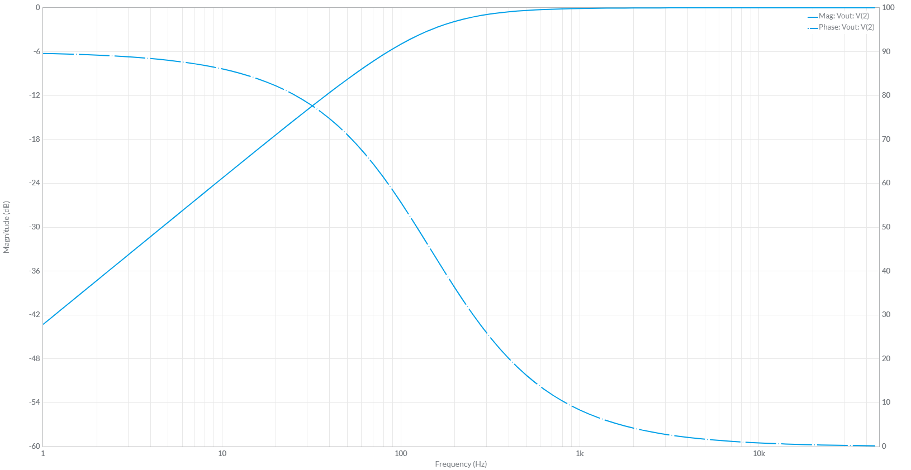

Since the level-shifter forms a 1st order high-pass filter, the attenuation at the corner frequency is -3dB and given by the following equation.

The capacitance C in this equation is the 68nF capacitor in Figure 7. The resistance in this equation is formed by the parallel arrangements of the two halves of the potentiometer to ground.

This might be confusing, so let me explain. Since any DC voltage looks like GND to an AC signal, the 5V side of the potentiometer is at the same potential as the GND side of the potentiometer to an AC signal. When the 100kΩ in potentiometer in Figure 7 is set to 2.5V, the center tap is 50kΩ away from GND and 50kΩ away from 5V. To an AC signal this looks like a pair of 50kΩ in parallel to GND; 25kΩ. Thus, when the 100kΩ in potentiometer in Figure 7 is set to 2.5V, the corner frequency of the high-pass filter is given by the following equation.

Let’s experiment with this idea to see how changing the bias point of the level shifter effects the corner frequency of the unintended high-pass filter. To do this, complete the following items.

1. Complete the following items.

* Set the potentiometer to 80% in MultiSim Live,
* Compute the effective resistance of the potentiometer that is set to 80% to an AC signal,

**20kΩ || 80kΩ = 16kΩ**

* Compute the corner frequency using the equation above,

**The corner frequency is 1/(2*pi*16kΩ*68nF) = 146Hz**

* Run an AC Sweep to generate the Bode plot and verify the computed corner frequency

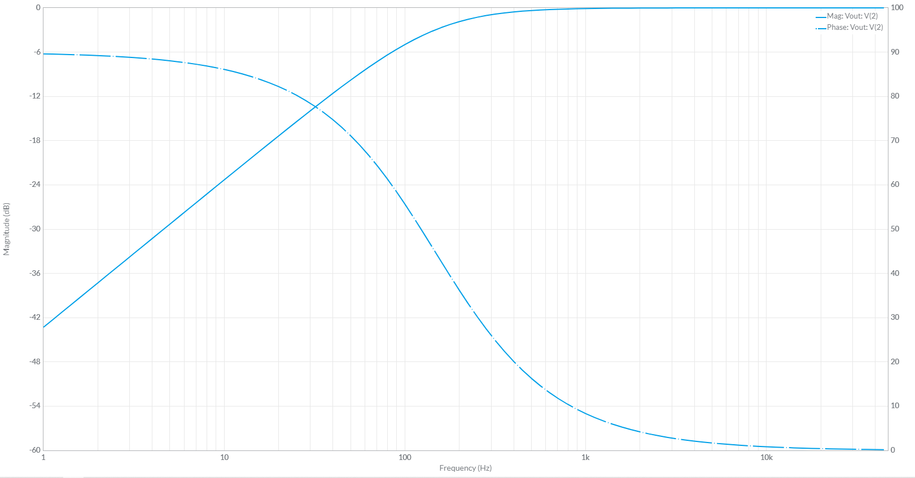

# Audio Board Filter Interface:

The audio board was designed with a low-pass filter (LPF), band-pass filter (BPF), high-pass filter (HPF) and a level-shifter (LEVEL) shown in Figure 1. Each of these four circuits has an input and an output. The four inputs are grouped together in the four header pins labeled with a whit silk screen INPUT in Figure 1. The outputs are grouped and labeled OUTPUT. You will use this pair of headers to run signals through different filters as follows:

* Connect a jumper wire from AUDIO_IN to an (LPF, BPF, HPF or LEVEL) INPUT pin then,
* Connecting a jumper wire from the associated (LPF, BPF, HPF or LEVEL) OUTPUT pin to AMP_IN.

Though not part of this lab, this setup allows you to run an audio signal through a filter and hear how it effects the audio output. You can even cascade several filters together by connecting one filter output to another filter output. This will allow you to hear how the audio signal is affected by one or more filters. For this lab, we will use the Rigol DG1022Z function generator to provide consistent signal input to everyone’s Audio board through the AUDIO_IN header pin.

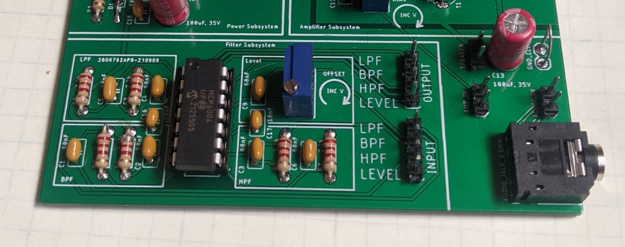

Figure : The filter subsystem allows you to experiment with different filters.

Take a moment to review the front panel of the function generator shown in Figure 2, we will be referring to these names later in the lab.

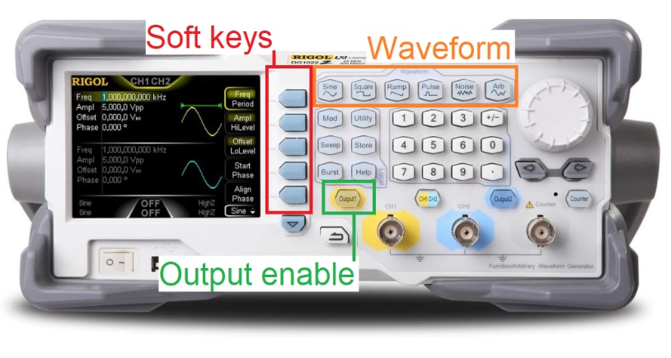

Figure : The Rigol DG1022Z function generator is a 2-channel function generator.

**Filter Behavior Experimental**

You will now draw the Bode plots of the filters using the test and measurement equipment. While there are a lot of instructions, once you have everything properly setup, this process goes quick. In other words, don’t be intimidated by the length of the instructions.

**Step 1: Setup the function generator:**

The first step in measuring your filter behavior is to properly setup the function generator output. If you do this step improperly, then you may damage the op amp in your audio board. This will result in you wasting time yours’s and the TA’s time troubleshooting your Audio board. A little extra time here is good insurance.

The procedure to setup the function generator is given in list below. Each step is lettered A…K to correspond to letters in the Figure 8.

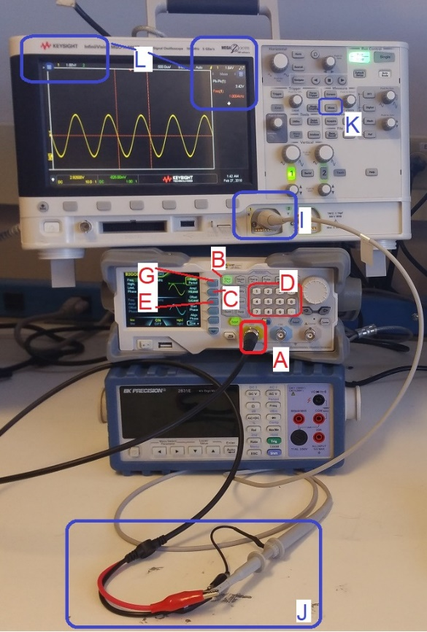

Figure : The test and measurement setup to check the signal input. Please DO NOT stack the equipment as pictured – this was done to fit all the equipment in one picture.

In the following procedure, dedicated keys are denoted with bold text in square brackets. Softkey are shown highlighted.

1. Connect a proper signal generator cable to the yellow BNC connector labeled "CH1" on the Rigol DG1022Z function generator. Insert firmly and twist until you feel it click. Give it a tug to make sure the BNC connector is securely mated,
2. If the **[Sine]** function key is not illuminated, press to illuminate it,
3. Press the Ampl/HiLevel softkey to highlight "HiLevel",
4. Enter 5.0 on the numeric keypad, and then press the Vpp softkey
5. Press the Offset/LoLevel softkey to highlight “LoLevel,
6. Enter 0 on the numeric keypad, and then press the Vpp softkey
7. Press the Freq/Period softkey to highlight “Freq”,
8. Enter 1.0 on the numeric keypad, and then press the kHz softkey
9. Connect a proper oscilloscope probe to the channel 1 input of the oscilloscope. Adjust the vertical scale to 1V/div and the horizontal scale to 500us, make sure that channel 1 is DC coupled, and that the trigger level is around 2.5V,
10. Connect the function generator and oscilloscope cables, black clip to black clip and red clip to scope probe,
11. Adjust the scopes so that they display frequency and the peak-to-peak amplitude of the waveform.
    * **[Meas]** → Clear Meas → Clear All
    * **[Meas]** → Source → 1
    * **[Meas]** → Type → Peak-Peak → Add Measurement
    * **[Meas]** → Type → Freq
    * **[↑ Back]**

Once complete, you should see the audio waveform on the oscilloscope oscillating between the ground reference and 5V. Only when you are sure that your function generator is setup correctly should you move to the next step.

**Step 2: Apply signal to the filter and measure input/output**

You are now going to use the function generator to send sin waves with varying frequencies into the LPF input and measure the amplitude and phase shift of the output waveform.

* Install female end of a male/female jumper wire onto the INPUT LPF pin,
* Install female end of a male/female jumper wire onto the OUTPUT LPF pin,
* Turn the function generator off by pressing the **[OUTPUT]** key,
* Attach the black ground clip of the function generator to a ground loop on the Audio board,
* Attach the black ground clip of the oscilloscope probe to a ground loop on the Audio board,
* Configure your oscilloscope,

|  |  |
| --- | --- |
| Horizontal (scale) | 1ms |
| Ch1 probe | INPUT LPF (male end of jumper wire) |
| Ch1 (scale) | 2V/div |
| Ch1 (coupling) | DC |
| Ch2 probe | OUTPUT LPF (male end of jumper wire) |
| Ch2 (scale) | 2V/div |
| Ch2 (coupling) | DC |
| Trigger source | 1 |
| Trigger slope | ↑ |
| Trigger level | 2.5V |

* Configure your oscilloscope to measure to the attenuation and phase shift of the filter,
  + [Meas] → Type → Phase
  + [Meas] → Setting → Source1: 2
  + [Meas] → Setting → Source2: 1
  + [Meas] → Add Measurement
  + [Meas] → Type → Ratio - Full Screen
  + [Meas] → Add Measurement
  + **[↑ Back]**
* Attach the red signal clip of the function generator to male end of jumper wire attached to the INPUT LPF jumper wire,
* Verify that everything is setup correctly by comparing your setup to Figure 9,

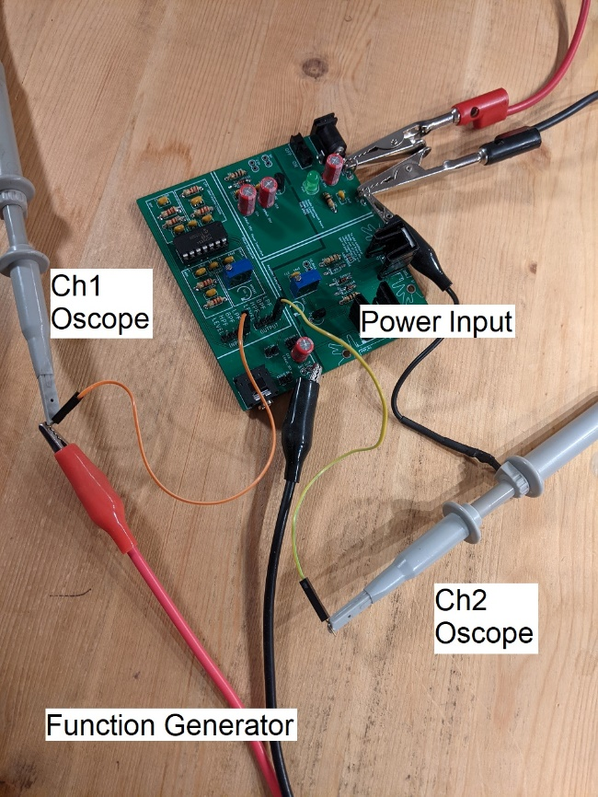

Figure 9: The setup to apply a signal to the LPF and measure the response on the oscilloscope.

* Enable the function generator output
* Observe the oscilloscope, it should look something like Figure 10,

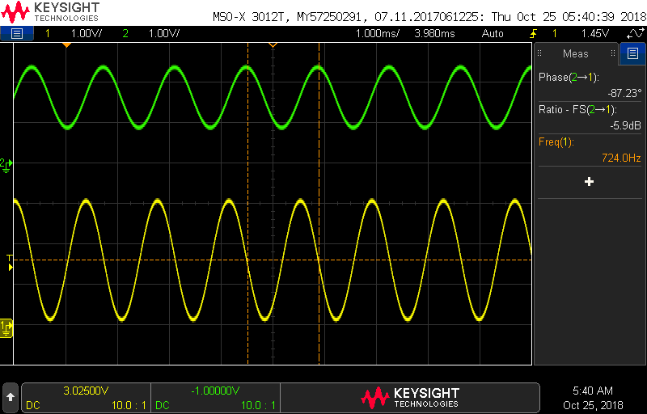

Figure : The input and output of the low-pass filter.

Now you are ready to collect the data to draw your Bode plot for the low-pass filter. Open the filterBehaviorWorksheet you downloaded earlier in the lab and select the LPFexp tab. Set the function generator to each frequency listed in column B and record the attenuation and phase measured by the oscilloscope into the respective columns. As you add these data values, the Bode plots will automatically graph this data.

Before jumping in and measuring all the values, please take a few moments to read over the following list of points; it will save you from having to repeat measurements.

* If a cell in the Freq column does not have an entry, find the frequency (by adjusting the function generator) that generates the gain or phase listed in that row.
* At low frequencies, the Gain and Phase measurements will not be reliably reported by the oscilloscope. Please just use the default values provided in the Excel file.
* The oscilloscopes will display phase values in the range [180° to -180°]. You should plot your phase delay over the range [0° to -360°]. Thus, if the oscilloscope displays a phase of 170°, correct this by subtracting 360° yielding (a mathematically equivalent) -190°.
* As you increase the input frequency to around 10kHz, it will become very difficult to measure the magnitude and phase of the output waveform. When this happens, make the following modification to the oscilloscope:
  + Switch channel 2 into AC coupling, by pressing the channel 2 button and select Coupling: AC. Move the channel 2 ground reference to the middle of the upper half of the display,
  + Use the acquire function to average together several channel 2 waveforms. **[Acquire]** → AcqMode → Averaging → #Avgs: 128. You will notice that the waveform updates occur much more slowly and morph whenever you change the frequency. However, you will be able to measure incredibly small amplitudes (down to about -60dB) in this mode,
* You will see the gain of the Bode plot start to rise at the high frequencies. This is a result of the fact that our circuit has a non-zero amount of inductance For more information check out [EEVblog #859 - Bypass Capacitor Tutorial](https://www.youtube.com/watch?v=BcJ6UdDx1vg) and jump to 11:44.

Include the Gain and Phase plots as the answer to this question.

To save the image on the screen

* + [Save/Recall] → Save → Format → 24-bit Bitmap image (*.bmp)
  + [Save/Recall] → Save → Press to Save

Now create the Bode plots for the high-pass, band-pass and level shifter using the respective tabs in the Excel spreadsheet. Make sure that the level shifter is set to 2.5V bias.

# Turn in:

Make a record of your response to numbered items below and turn them in a single copy as your team’s solution on Canvas using the instructions posted there. Include the names of both team members at the top of your solutions. Use complete English sentences to introduce what each of the following listed items (below) is and how it was derived.

**Filter Behavior Simulation**

**Low-pass filter** Steps 1 – 6 of analysis

**High-pass filter** Steps 1 – 3 of analysis

**Band-pass filter** Steps 1 – 3 of analysis

**Level shifter**  Steps 1 – 6 of analysis

**Filter Behavior Experimental**

**Low-pass filter** Excel Bode plot

**High-pass filter** Excel Bode plot

**Band-pass filter** Excel Bode plot

**Level shifter**  Excel Bode plot